Please Stop Your Witchcraft Against Us-PLEASE! You Are at Serious Risk
December 25, 2016
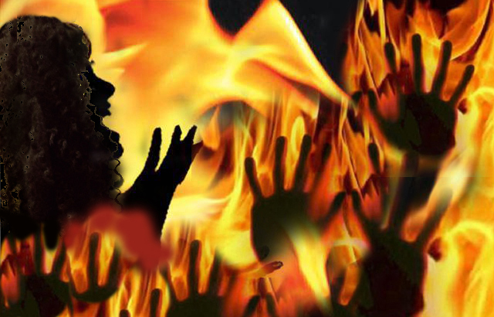
May the confidence in God’s protection reign in your hearts.

Oh, my dear Heartdwellers, don’t dabble with evil. Don’t even consider it for a moment. How dangerous it is! The former employee who had taken to voodoo against us is now being used by powers and forces much greater than they understand.

Because we have so many enemies, they are now turning their powers like a conduit running them through this former employee. As a result, these very seasoned and powerful Satanists are using this person, and the power and heat running through them is SO intense that they are beginning to burn up from it. The Lord likened it to radiation earlier. That radiation has consequences in our body.

The three people involved in this cursing against us are now being overpowered by forces they have no way to handle. If you are listening to this, dear friend, please put aside your anger, your bitterness and jealousy and call on Jesus right now, before it is too late. You are in grave danger, you are being used by those far advanced in the black arts and you have been chained by them with no hope of escape on your own powers.

Please do not let Pride stop you from calling on Jesus. You are headed for disaster, you and the two working with you. Please, please, He loves you. Call on Him, He wants to help you get free. Please, do not continue on this path. There are curses against you and your bodies are being exposed to strong radiation to create reproductive, fast-moving cancers that will take your bodies over. Please, please, because you have cursed the innocent, you are not being protected and these curses are about to take root in your bodies if you don’t stop immediately.

Please stop, please stop, PLEASE! What you have done to hurt us is only being used to train us for further battles. The Lord heals our wounds and we offer them to Father God for you, for your conversion. But you are in a serious situation that will claim your life if you do not stop it. Please heed my plea. There is nothing you can do to us that God does not turn to double blessing in our lives, but you have done great harm to yourselves.

We are all praying for you, really praying hard. We are begging you to stop before it is too late for you. A few days ago your conscience cried out to you to stop. That was because you had been told not to cross a line, but you ignored that. Now the consequences of ignoring the warning are upon you and you have no time left to repent. You are in a bondage to those far more powerful than you. They have chained you and the only way out is to cry out to Jesus and let Him come and wrap His loving arms around you and break the chains off. Give you a total change of heart.

By all means, watch the movie about St. Patrick and see what happened to the Druids that challenged St. Patrick’s God by the trial of standing in a hut that was set on fire. See what happened there and understand: you are not fighting a person or a channel, you are fighting against your Creator. And the druid was consumed because he insisted on the challenge, believing that Patrick was pleading with him to stop, because he was afraid. That was a lie, Patrick had nothing to fear because God was with him and his disciple, but the druid was burnt alive while Patrick’s disciple walked out unharmed. The druid’s cloak was charred and burned while Patrick’s remained unharmed.

You are greatly loved by your Creator. Whatever has been done to you in your life to make you think otherwise is a lie. God loves you and He doesn’t want to see you harmed. He is not the one who abused you as a child. He cried when you were abused.

Lord, is there anything You wanted to add?

Jesus began, "This is a lesson in spiritual warfare, My People. You may be enticed to dabble in curses and see what you can do. It seems harmless at first…almost fun. The demons entice you, 'Come on you have great powers here, try this you will see how powerful you really are. That Christian isn’t powerful. She's a weakling and afraid of her own shadow. But you have real potential, you are specially endowed with powers, come on try it.

"And those at the witchcraft shops will also encourage you, sell you dolls, candles and books and encourage you to begin to learn these ways. Why should you put up with others doing you wrong? You can get even and make them suffer for their unfairness to you.

"And so you begin this new journey as an adventure thinking you are going to conquer and retaliate and make others suffer for what you perceive as unjust. You have bought into it. Soon the demons are courting you and showing you results, telling you all the things your powers have done to others to make them suffer. Soon you are seeing visions of swords piercing and poisoning, and making your enemies sick.

"You are quickly growing in confidence and boldness. As you begin to move in this direction, other forces are attracted to you. Others who also have a case against the ones you are cursing. They see how inexperienced you are and begin to court your favor with flatteries and channel their wicked powers through you as the focal point.

"The rush from the power at first makes you intoxicated and heady, but then a certain fear sets in...'What is happening to me? This is going too far, too soon. I'm afraid. I feel scared! I'm beginning to fear theses forces and powers - they are bigger than I am. But now you are locked in, and cannot get out. You overstepped a boundary and have been captured. Your soul begins to shrink back and hide in a corner, cowering, but you keep up the front that you are powerful. You are now being pulled under by these forces and there is only one escape. But you can’t appeal to Him, because those you hate have appealed to Him and you won’t lower yourself to ask for His help and do the same.

"It is all a lie, dear soul. A big lie. You have lost your freedom and I am your only way out. Do not delay. Call on Me in the day of trouble and I will deliver you. In spite of your sins, I will deliver you. I will forgive you. I will give you new life and a future worth living for. You have nothing to lose and everything to gain.

"But if you refuse to respond to My call of love, I have no choice but to release you to the will of your enemies. And you have many who have issues with you, who have gone to curanderas and had curses placed on you.

"I have held back much harm from your life, but now you must decide. Am I to cover, deliver and protect you? Or have you chosen to break free from Me and go your own way? Please consider these options when you feel free from arrogance and vengeance. You are not thinking clearly if these influences are controlling you.

"Ask Me to help you think clearly, please ask Me. I will help you make a clear decision. And I will be there for you if you choose to repent and call on My Name."

